[**Play Audio Listening Test 3 Q 1-10**](http://www.accessinstitutegroup.com/wp-content/uploads/2015/07/ListeningTest-3-Q-1-10.mp3)

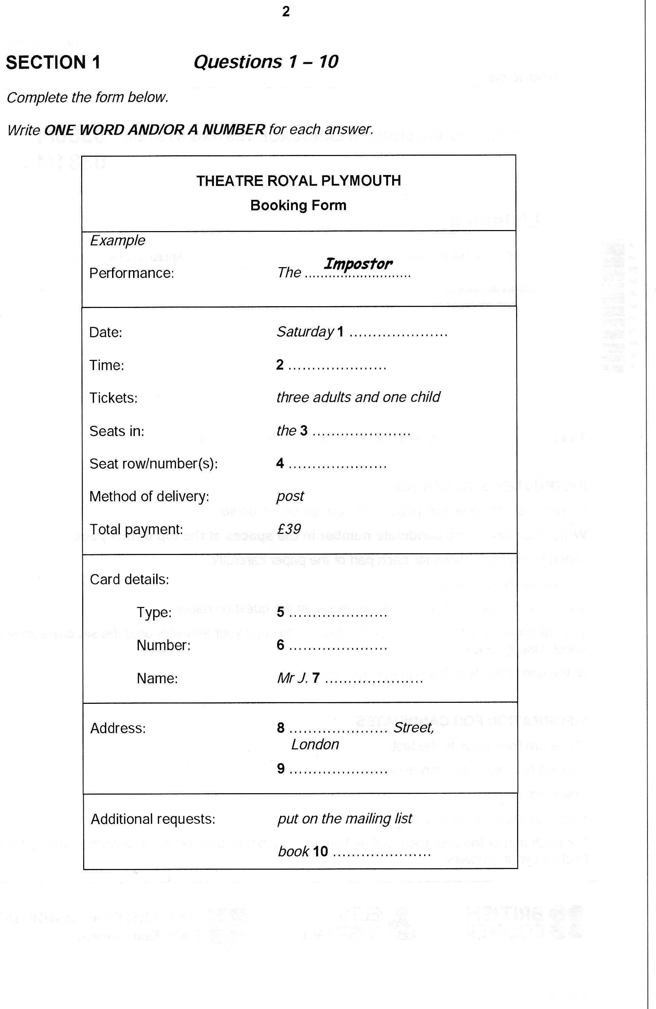

[**Play Audio Listening Test 3 Q 11-20**](http://www.accessinstitutegroup.com/wp-content/uploads/2015/07/ListeningTest-3-Q-11-20.mp3)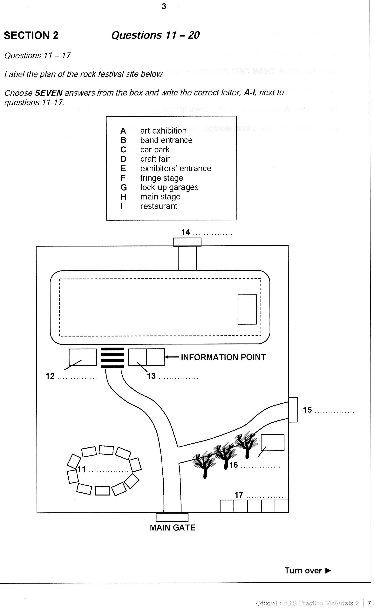

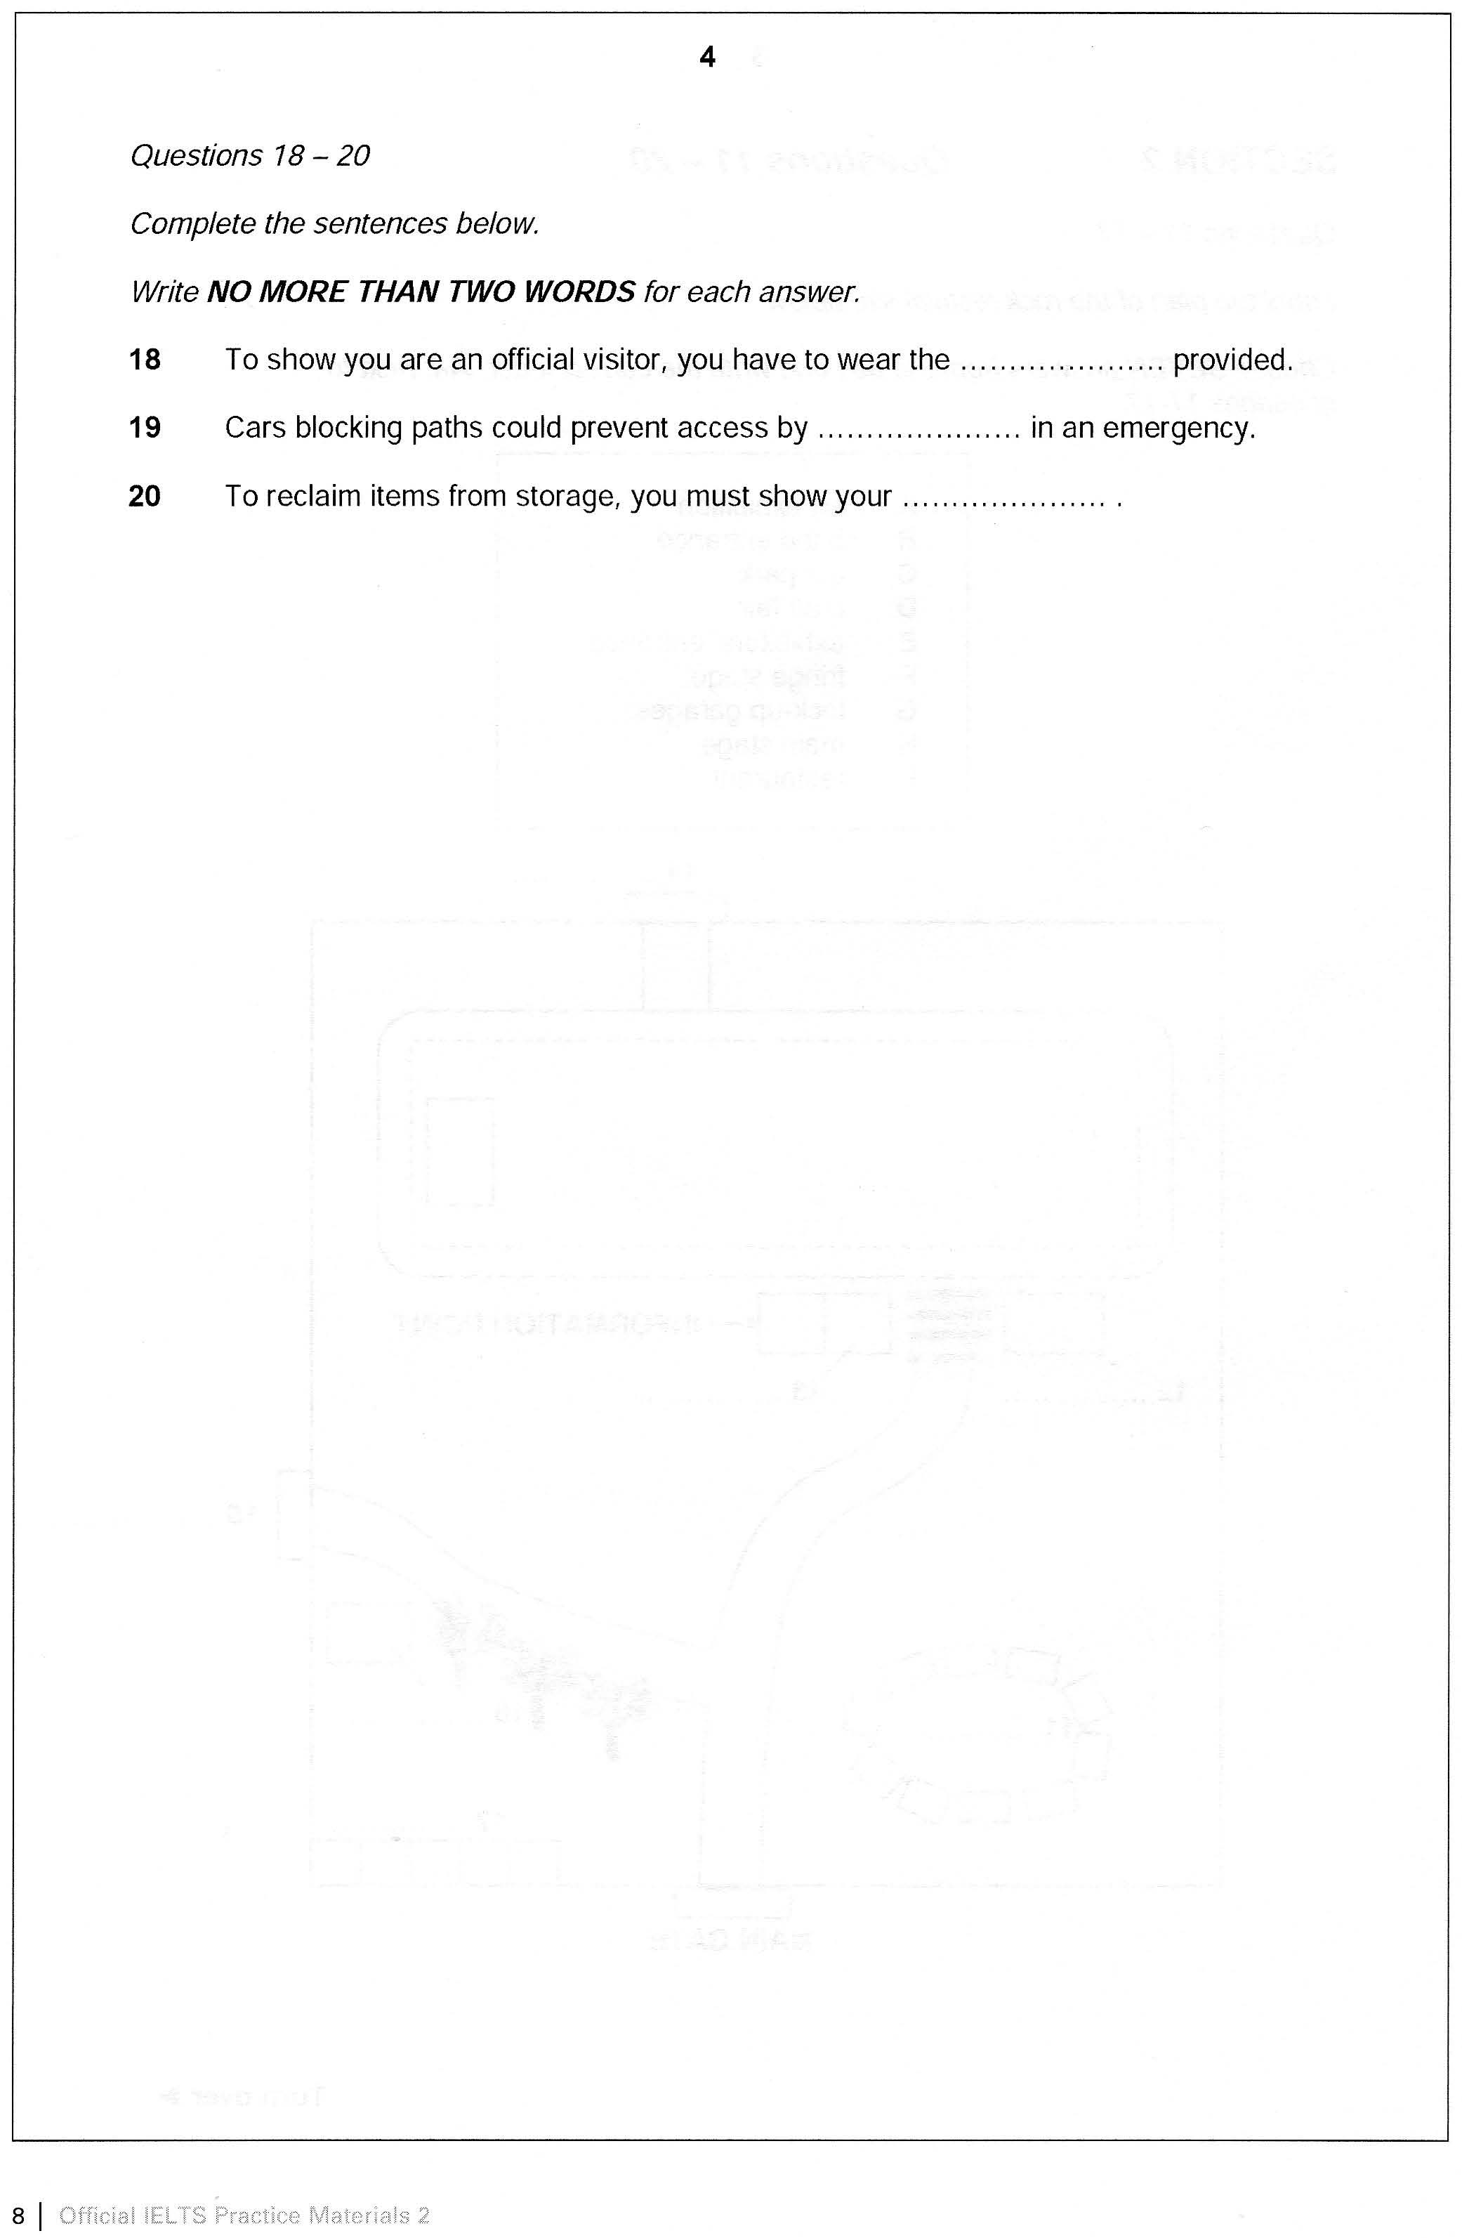

[**Play Audio Listening Test 3 Q 21-30**](http://www.accessinstitutegroup.com/wp-content/uploads/2015/07/ListeningTest-3-Q-21-30.mp3)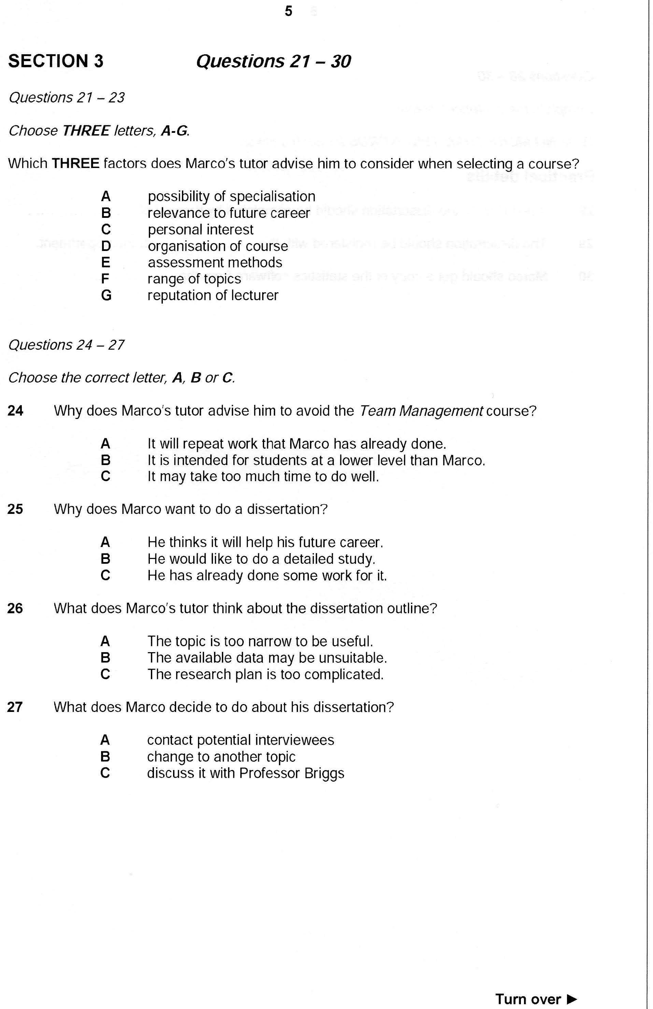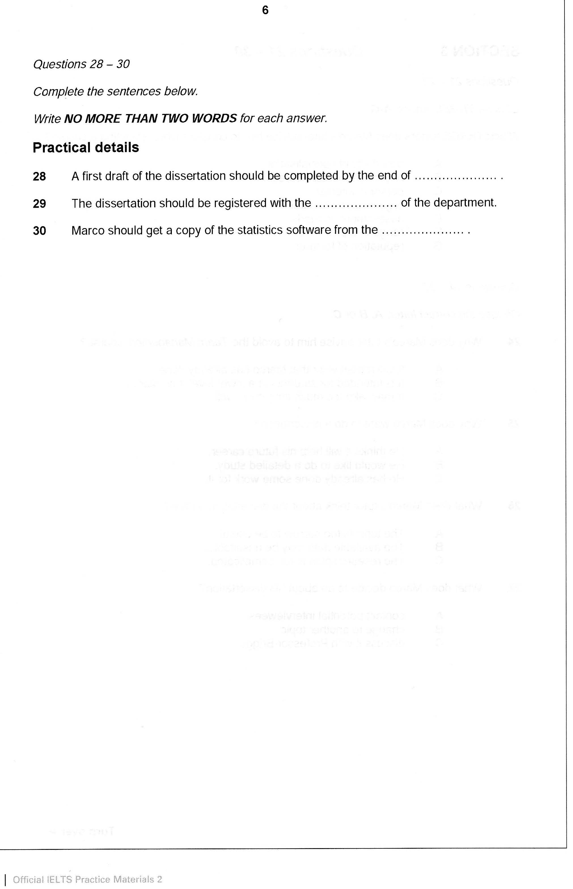

[**Play Audio Listening Test 3 Q 31-40**](http://www.accessinstitutegroup.com/wp-content/uploads/2015/07/ListeningTest-3-Q-31-40.mp3)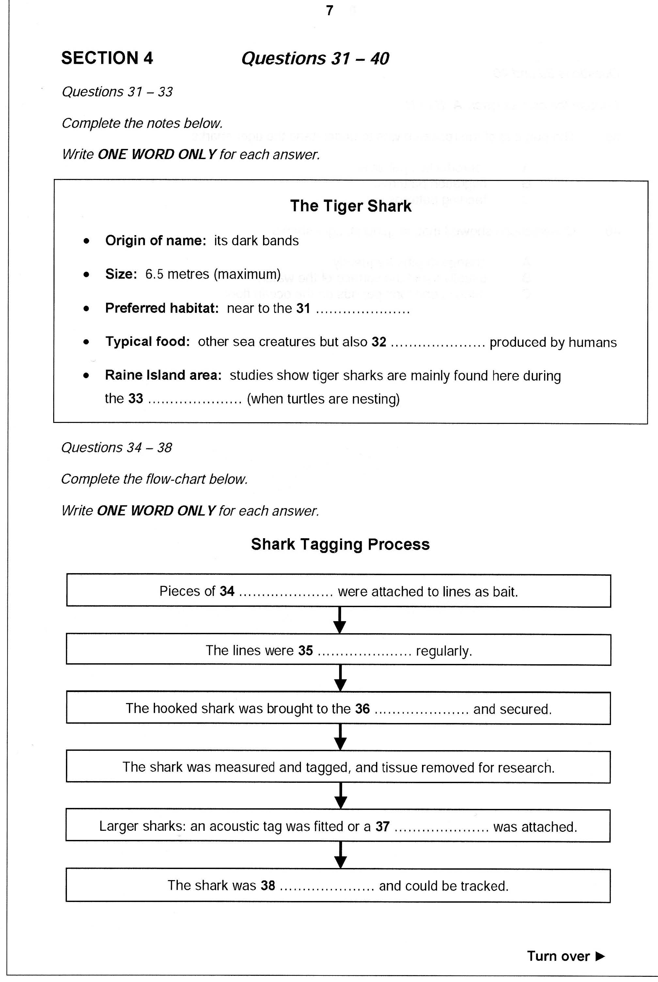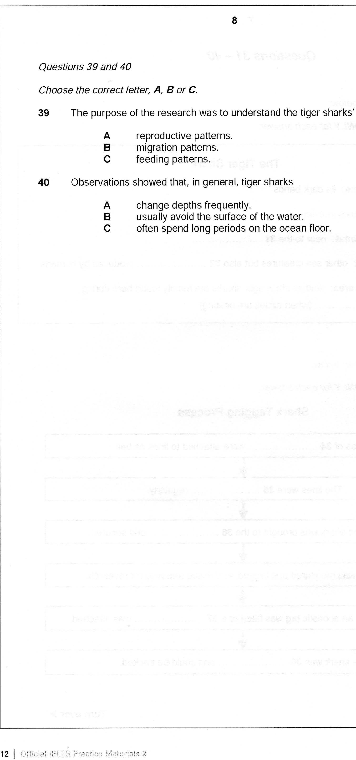

**Answer Key**